Smart Tender/Contract Management System Using Blockchain

In this project we are using Blockchain technology to secure Tender data as this technology has inbuilt support for data decentralization (which means data will be maintained or store at multiple servers and if one server hacked then its storage data hash code verification will failed and Blockchain obtained data from next working node) and data encryption with hash code verification.

Blockchain will store data as well as its hash code in RTREE structure and before storing new transaction it will verify hash code of all previous transaction and if data is not changed or hacked then its hash code will be verified and new block transaction will be stored. Blockchain will create contract and all details or data will be stored inside that contract. Blockchain is immutable due to its block verification before storing any new block. All data stored inside Blockchain is encrypted and associated with previous and current hash code

In propose project we are using following modules to store data in Blockchain

1. Tender Officer Login: Tender officer can login to application by using username as admin and password as admin and then will get new page. In new page officer can create tenders and all this tenders will saved inside Blockchain where each transaction will link with previous and new transaction hash code. Officer can evaluate bid to choose winner and the bidder with high bid will be selected as winner. Officer will send notifications to all bidder about winner
2. Bidder: Bidder can signup with the application and then login to application and then can view all tenders and bid to each tender and can view status of tender winner.

Below screen shots showing code of Blockchain

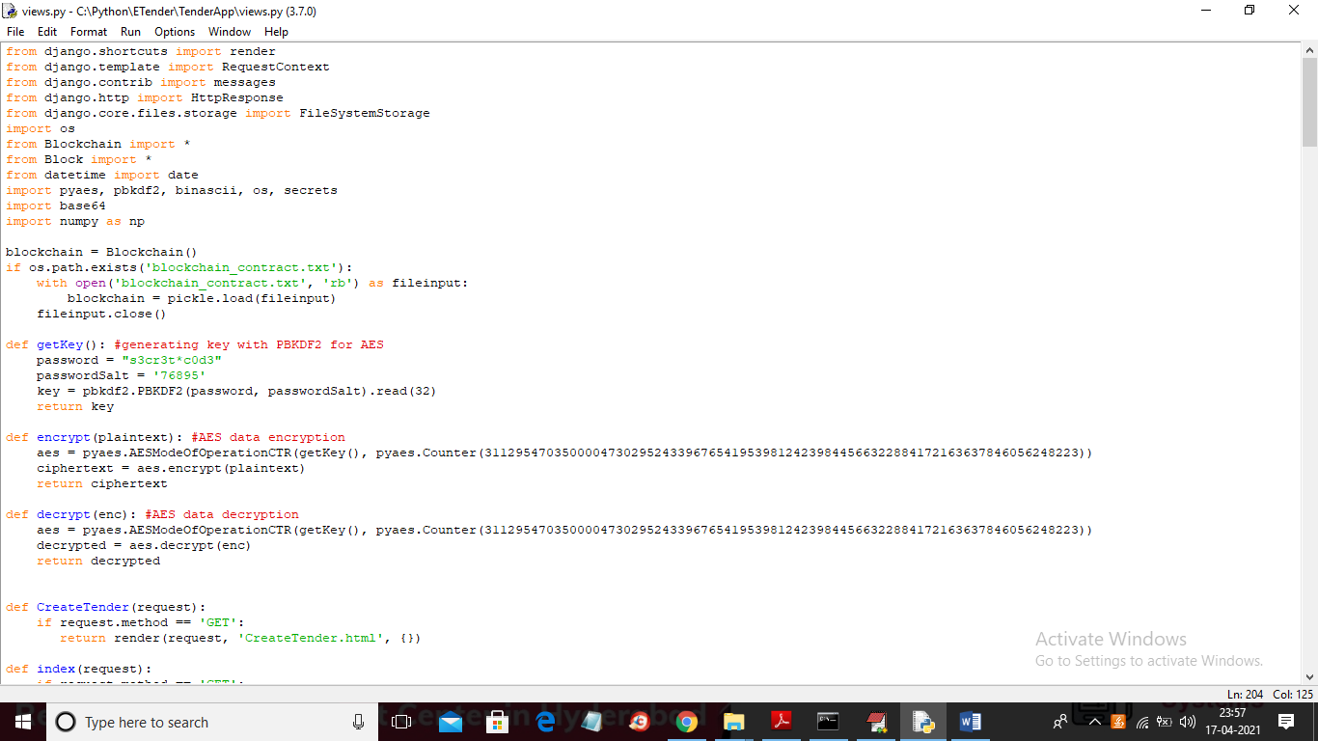

In above screen you can see red colour comments where we mention we are using AES algorithm to encrypt each transaction before storing in Blockchain

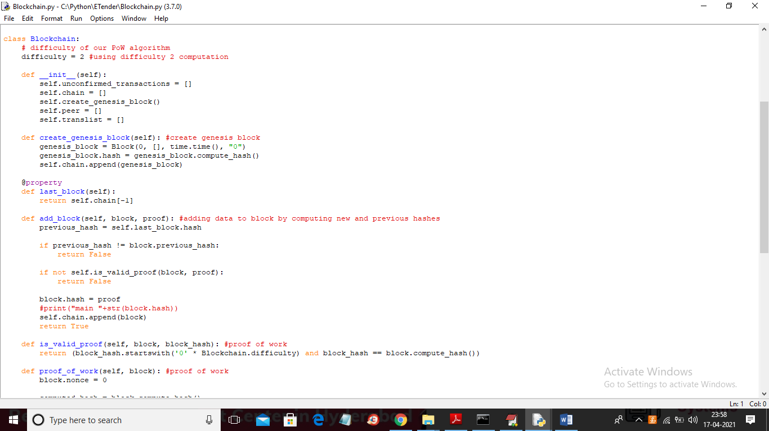

In above screen you can read red colour comments to understand hash code generation and storage of data in Blockchain.

SCREEN SHOTS

To run project install python 3.7 and then install DJANGO package and then start server by double click on ‘run.bat to start Web Server and get below output

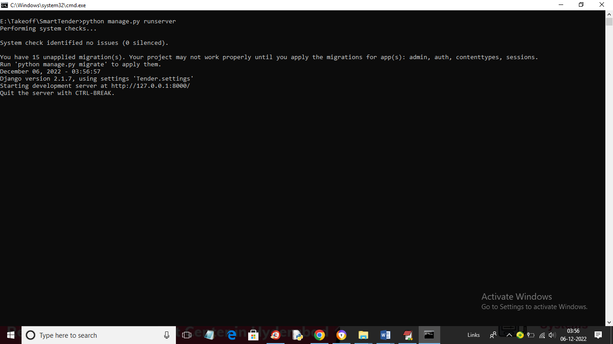

In above screen python server started and now open browser and enter URL as ‘http://127.0.0.1:8000/index.html and press enter key to get below page

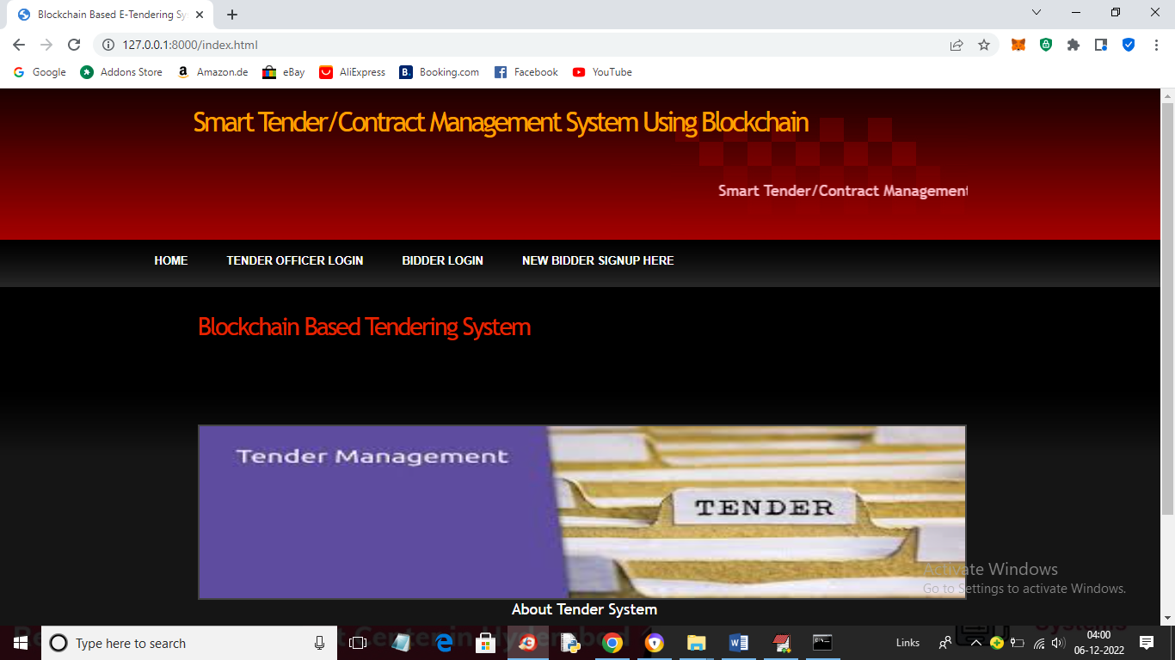

In above screen click on ‘Tender Officer Login’ link to get below login screen

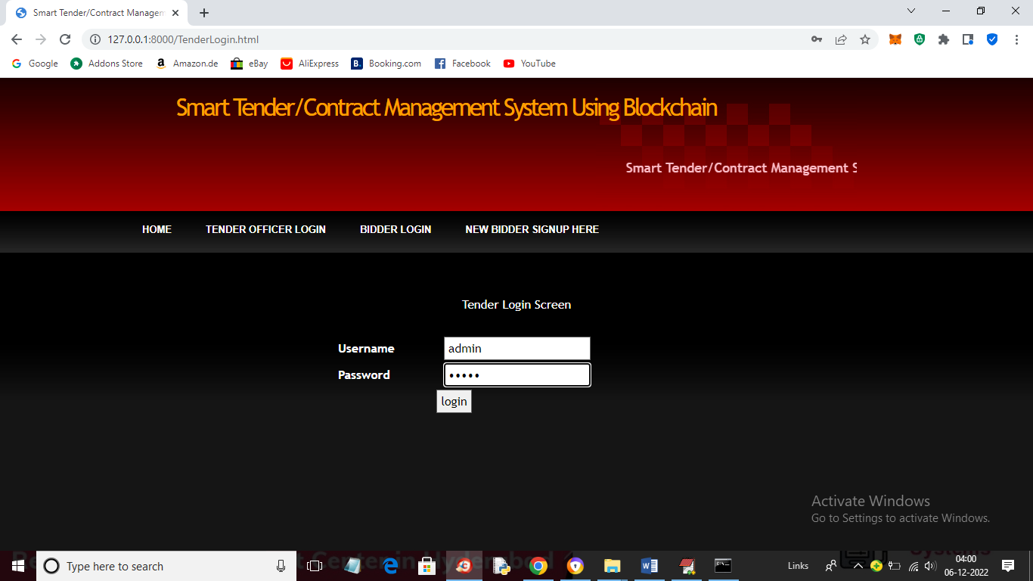

In above screen login as Tender Officer and then click on button to get below screen

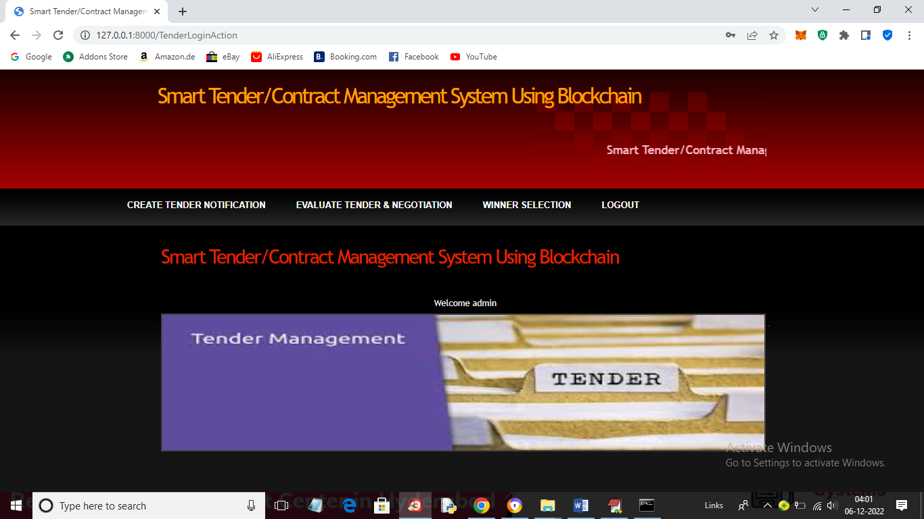

In above screen Tender Officer can click on ‘Create Tender’ link to get below screen and to create tender

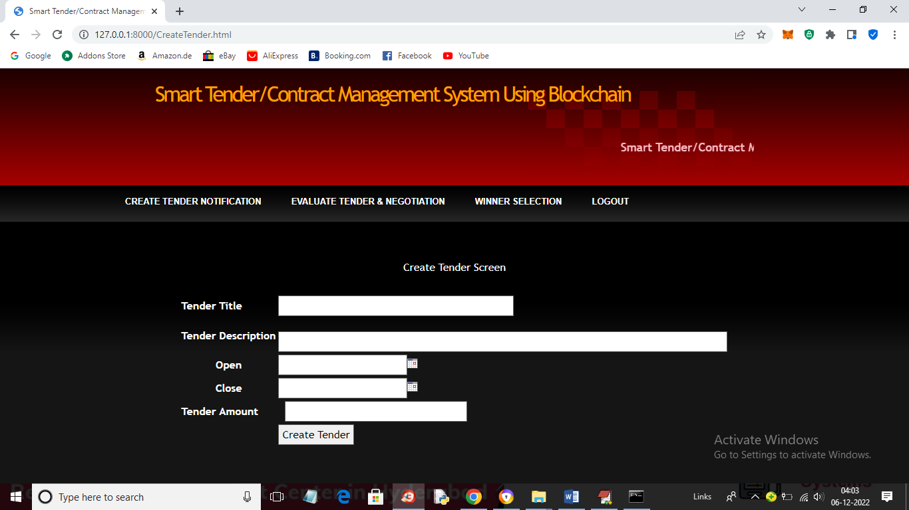

In above screen add new tender details and then choose open and close date and then enter tender amount like below screen

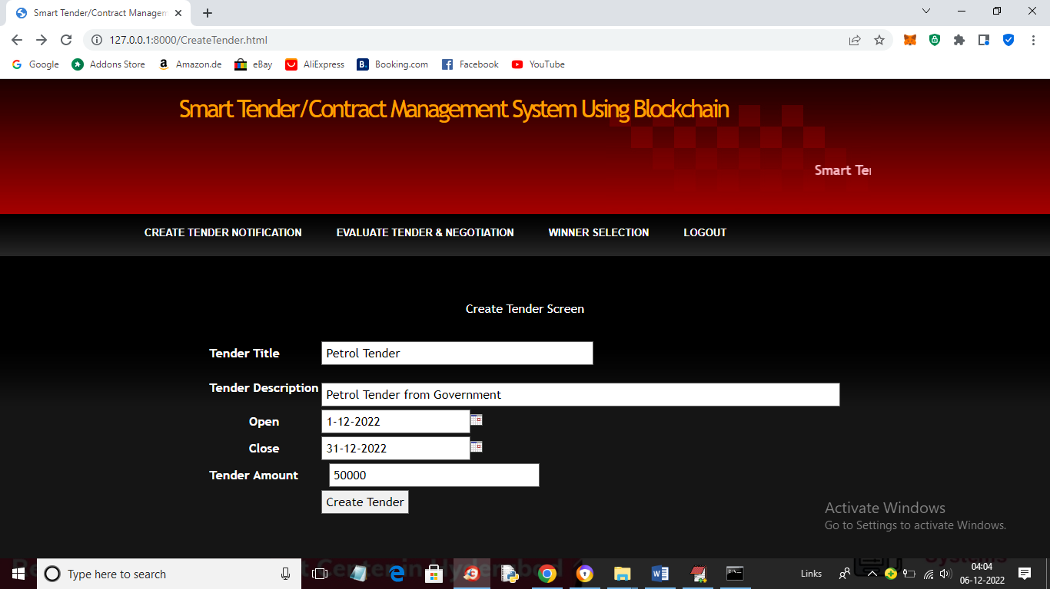

In above screen I entered some details to create tender and press button to get below screen

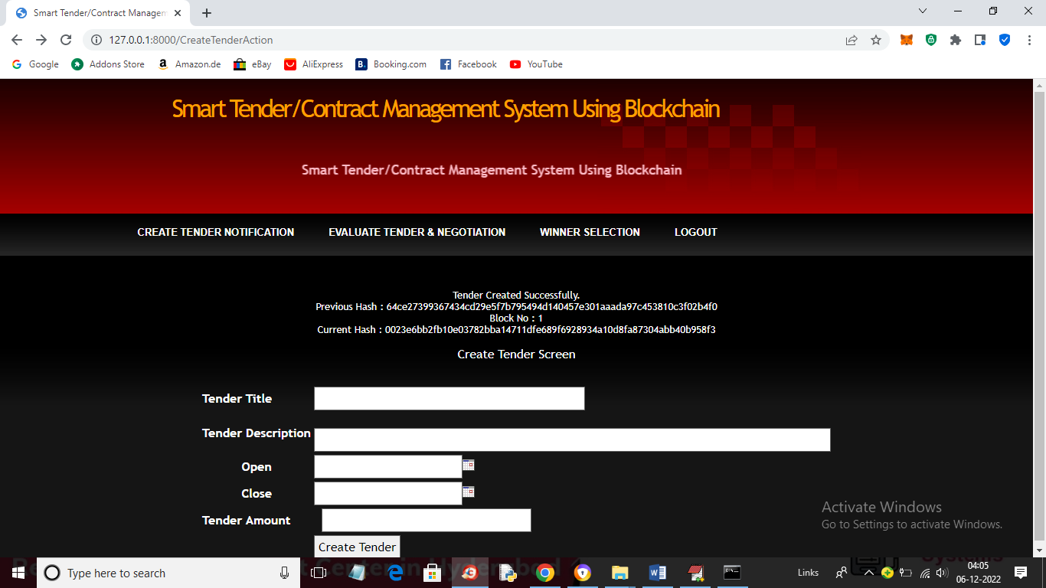

In above screen tender is created and details stored at Block No 1 and we can see Blockchain generated hash codes for previous and new records and now logout and signup, login as user to allow them to bid for this tender

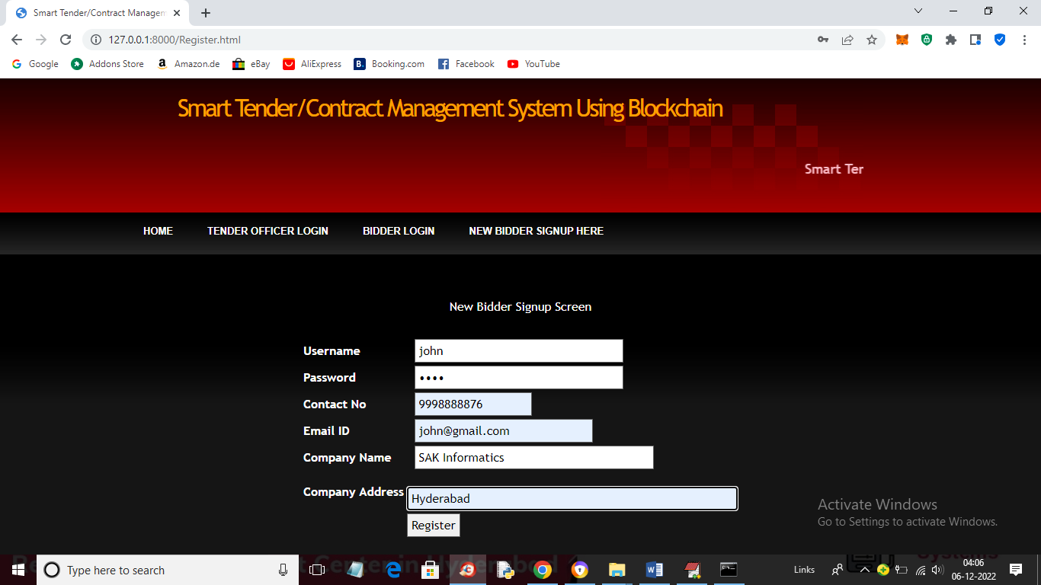

In above screen new bidder is signup and then click on ‘Register’ button to complete signup process and to get below screen

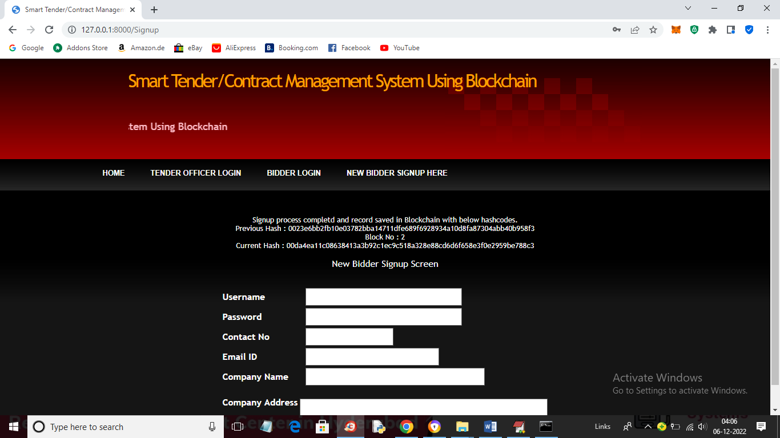

In above screen bidder details store in Blockchain at Block No 2 and we can see previous and current block hash code and similarly you can add as many user as you want. Now login as bidder

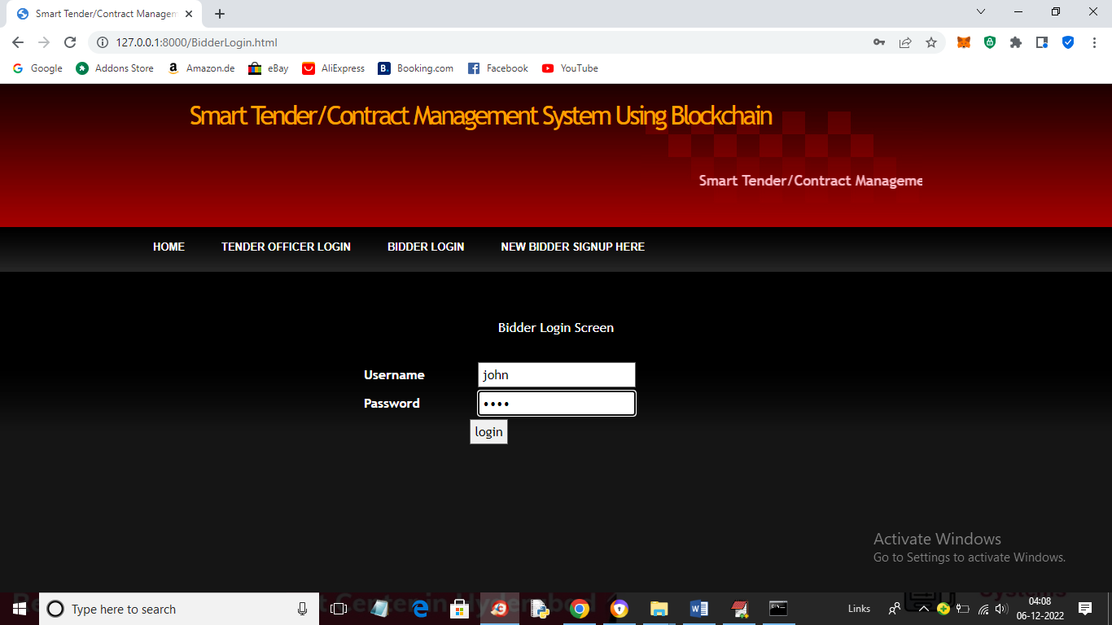

In above screen bidder is login and after login will get below screen

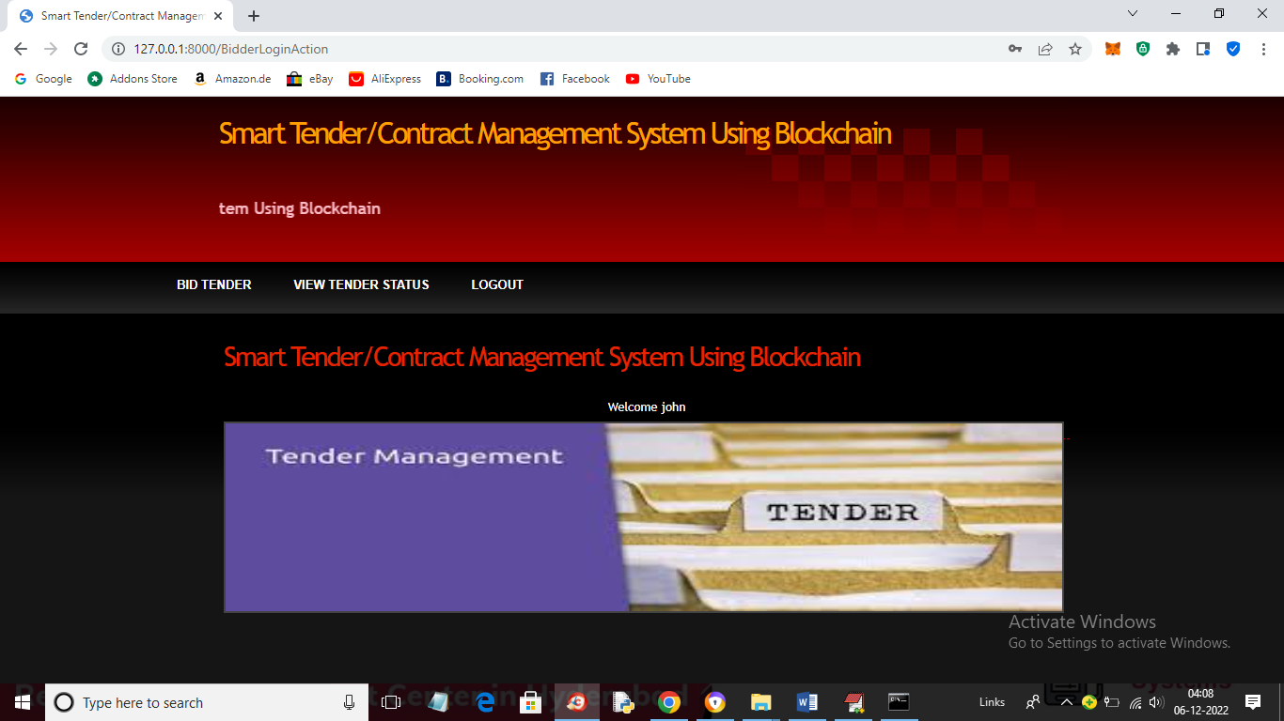

In above screen bidder can click on ‘Bid Tender’ link to get below screen

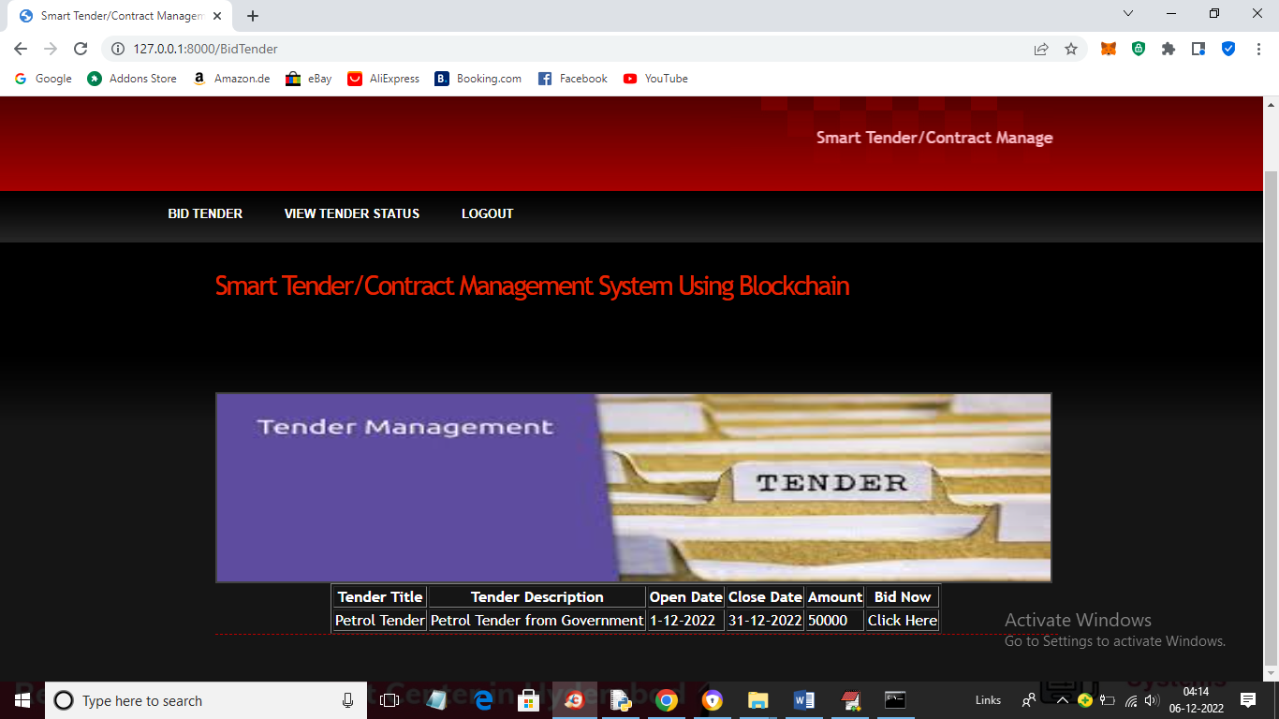

In above screen in table bidder can view all tender details and then click on ‘Click Here’ link to bid for that tender and get below output

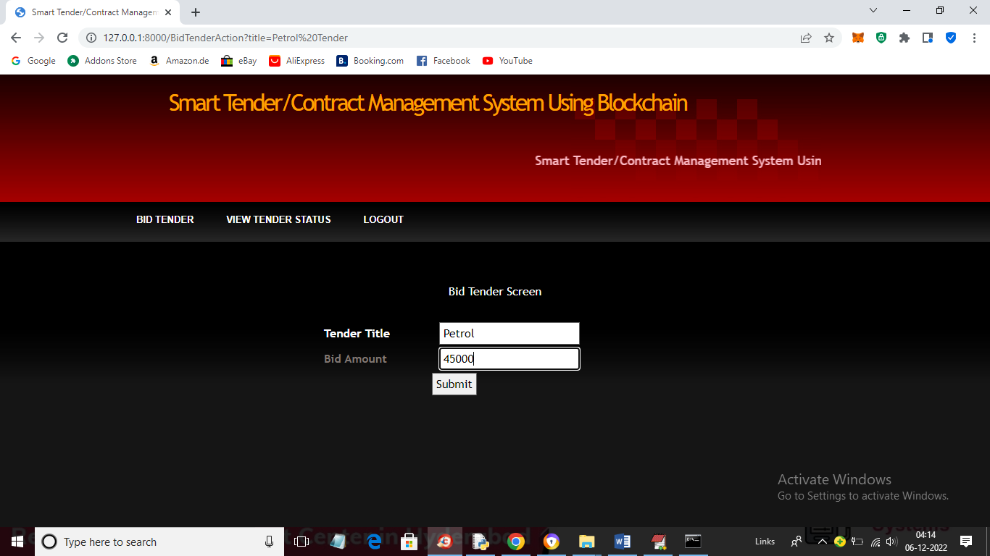

In above screen user ‘John’ bidding 4500 for this tender and get below output

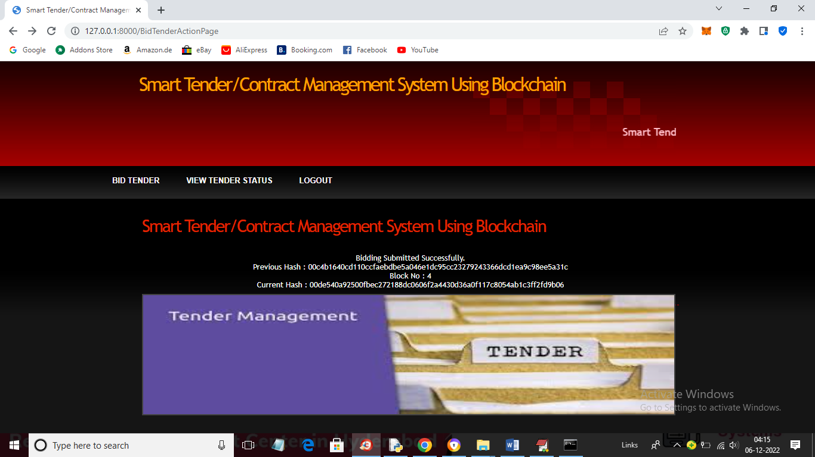

In above screen we can see Blockchain output for bidding and login as another user to bid for same tender

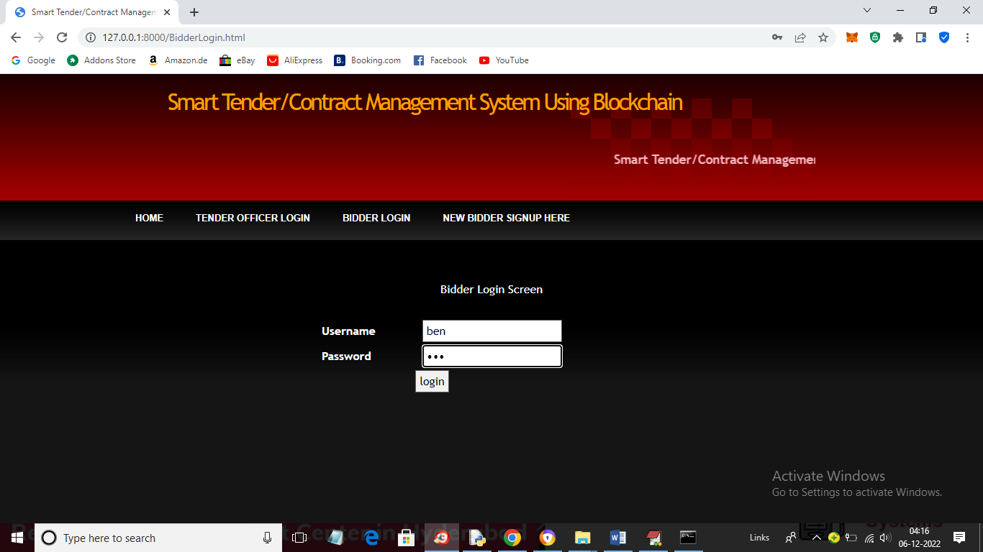

In above screen another user ‘ben’ is login and after login ‘ben’ can give bidding in below screen

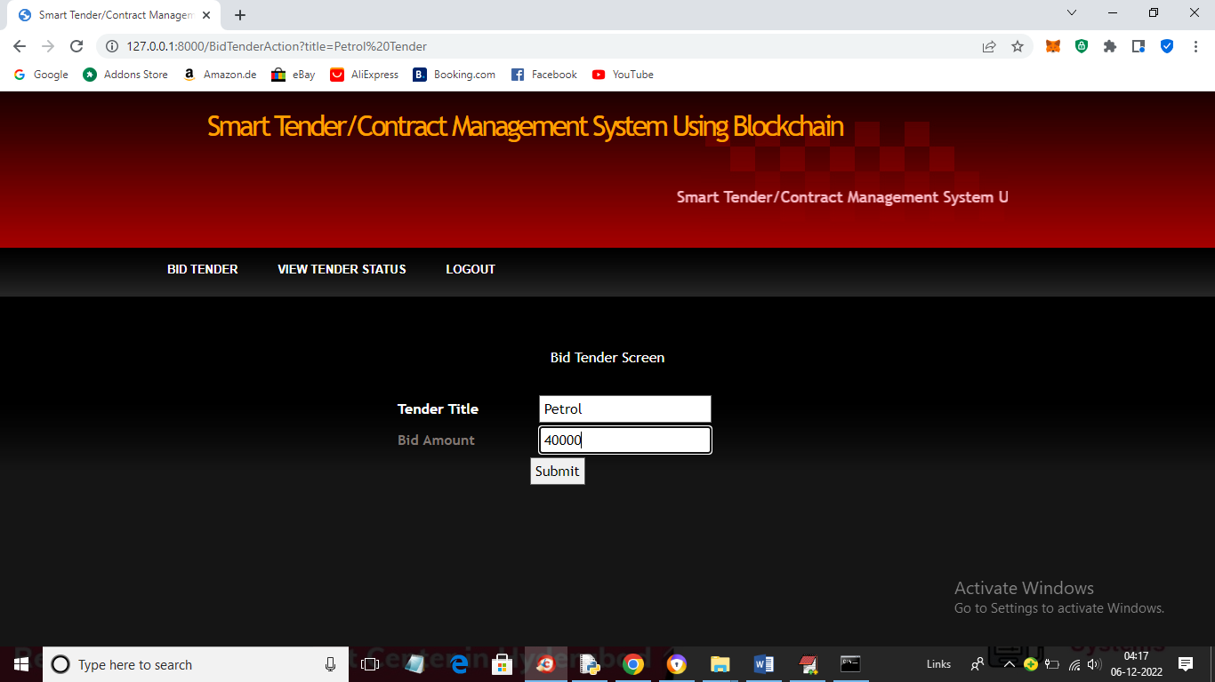

In above screen ben is giving 40000 bid amount which is lesser than john user amount and press button to get below output

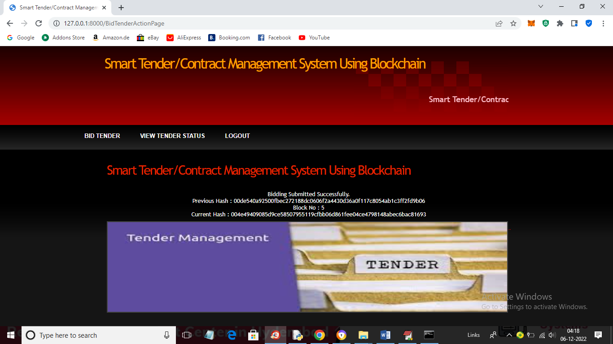

In above screen Ben bid also saved in Blockchain and now login as Tender Officer to view all bids and select winner

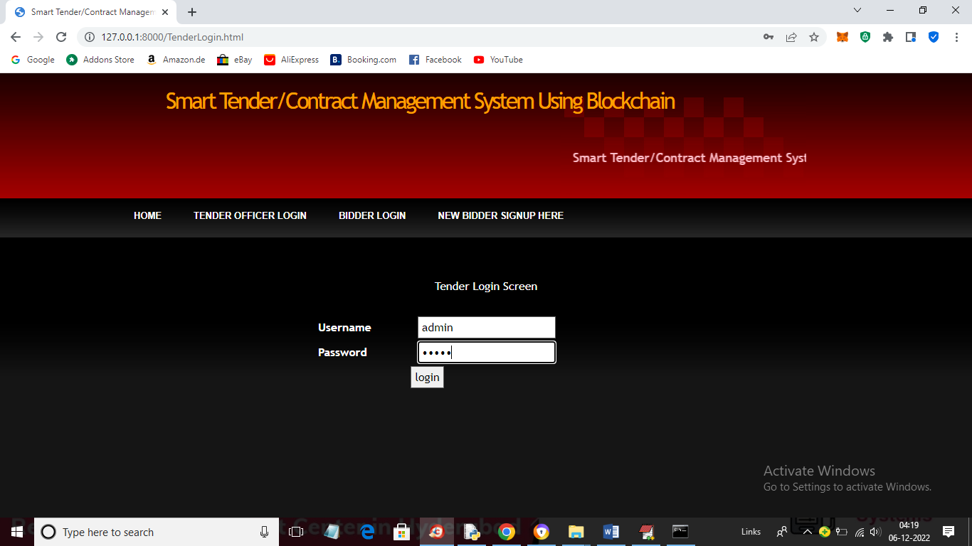

In above screen Tender Officer is login and after login will get below output

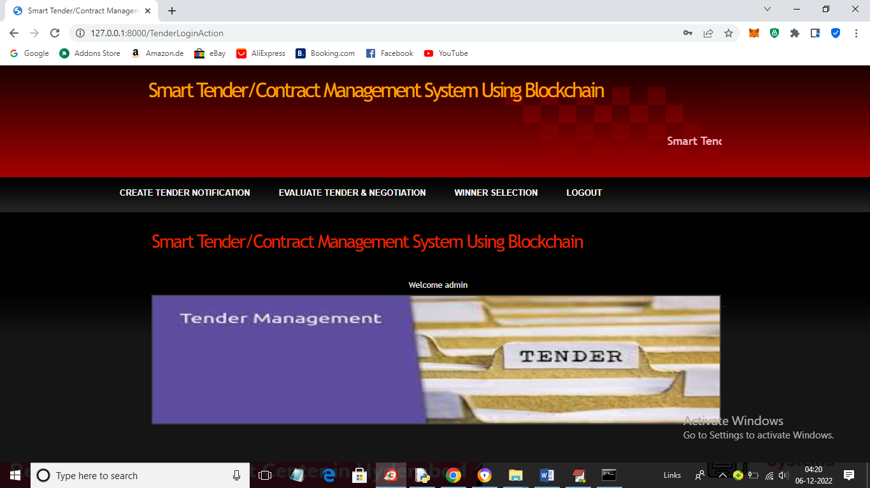

In above screen Officer can click on ‘Evaluate Tender & Negotiation’ link to select bidder giving high bid and will get below screen

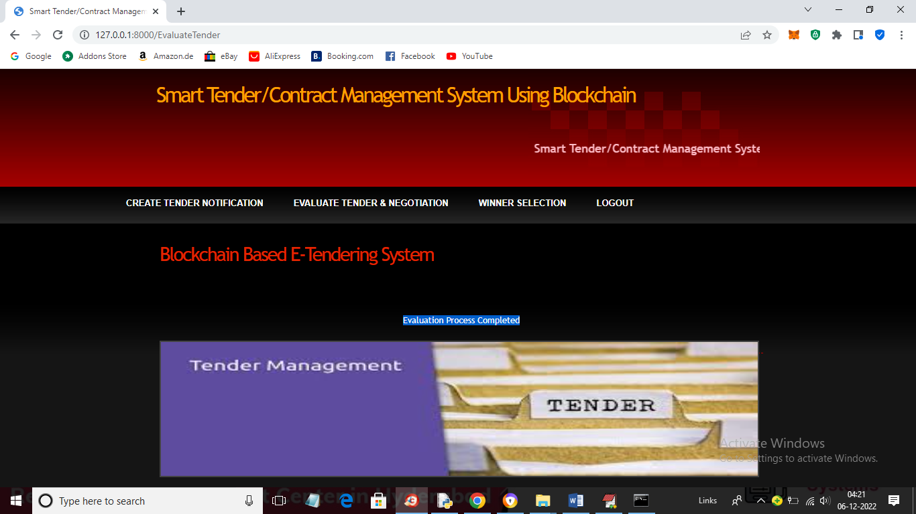

In above screen we can see in blue colour selected text that evaluation process completed and now click on ‘Winner Selection’ to get below screen

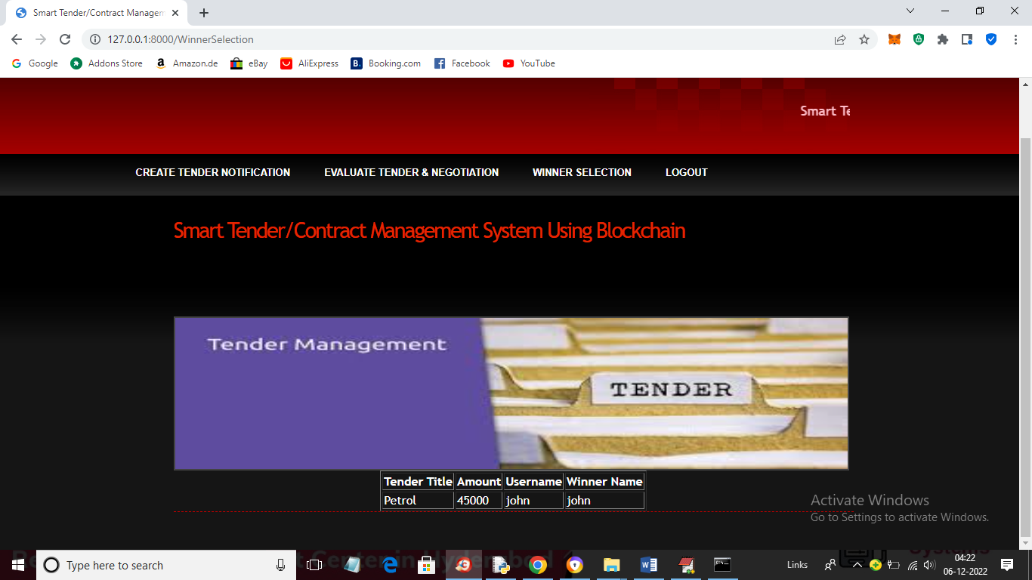

In above screen in table we can see both user ‘john’ and ‘ben’ bid for Petrol Tender but “john’ bid was high so ‘John’ was the winner and similarly you can login to bidder and can view tender status or winner.

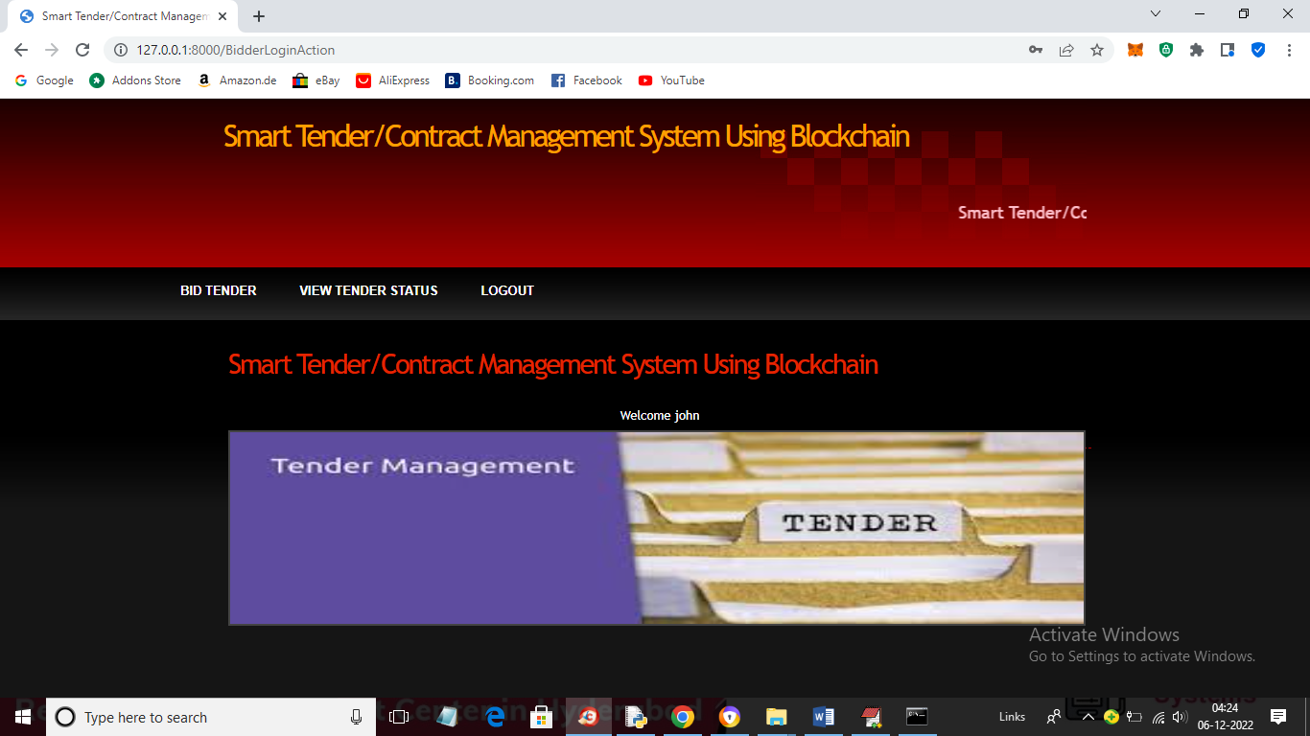

In above screen bidder can click on ‘View Tender Status’ link to get winner details

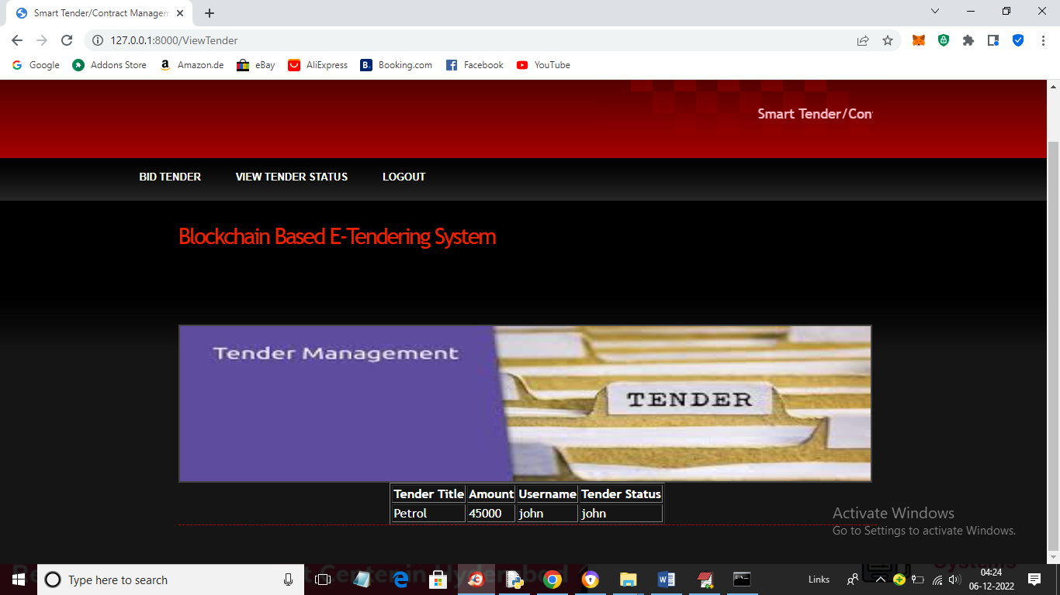

In above screen in last column we can see Tender Status won by user ‘John’ so all users will get notification that ‘Petrol’ tender won by ‘John’ and by login all they can see this winner notification.

In your requirement you ask to modify and delete tender but to modify data first we need to add some data so we replace this modify module with ‘Create Tender’ to add new tender details. You ask to delete tender also once after winner selected then that tender will be deleted automatically.

Note: while taking screen I make winner to that user who bid high and later I realize and changed code to make winner to user with less bid